The track diagrams below show the movement of two objects along the same reference frame, but starting at different locations. Object A moves to the right and Object B moves to the left. The location of each object is marked every 0.5 seconds. Each box represents 1 m. 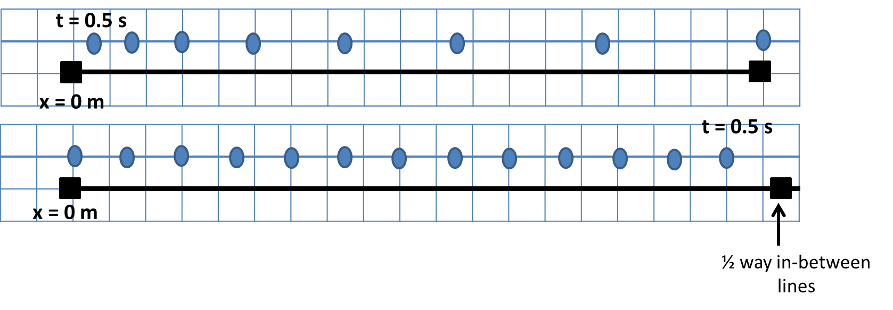
B
A
- Describe the motion of each object (left/right, speed up/slow down).

- Does either object accelerate? If so, is the acceleration positive or negative?

- What is the velocity of object B?

- What is the displacement of each object after 2 seconds?

- Are the two objects ever in the same place at the same time?

- What are the average velocities of object A for the first and the last second of the trip?

- What is the total time of travel for each object?

Draw motion diagrams for each object above. Be sure to label v_{i}, v_{f}, t_{i}, t_{f}, a, x_{i}, and x_{f}.

